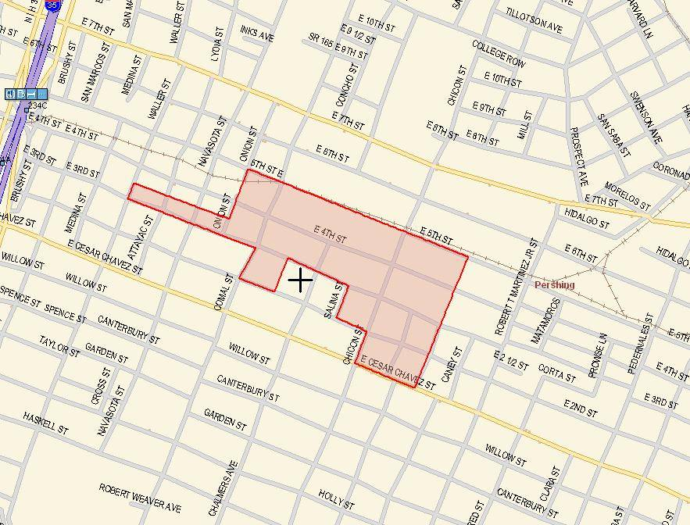
http://egpreston.com/K5GP-BPL.htm
Austin Facility
1
2
3
4
5
6
7
8
9
10
11
12
13
14

See http://egpreston.com/K5GP-BPL.htm for more pictures and audio files.

